CW & TWENTY HANDS HIGH BIO

“I know a good voice when I hear one. You need to be on stage”
~ Denver music icon Hazel Miller and longtime backup singer for Big Head Todd & the Monsters

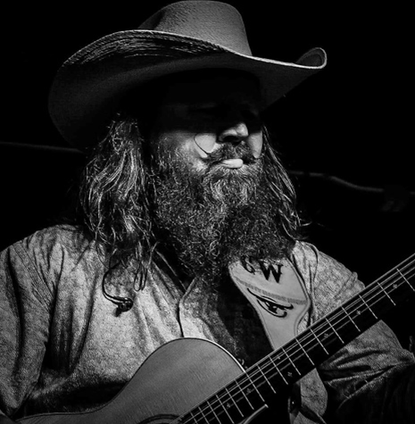
Photo credit: PAH Photography

One of country music’s hottest bands in the Rocky Mountain region, CW & Twenty Hands High is proof that there’s strength in numbers.

The band’s single “Back to Wichita” has grown from 133,000 plays – 58,000 on Spotify + 75,000 in retail stores Wal-Mart, Best Buy, Ace Hardware, Subway and more – to over 350,000+ across digital platforms and streaming outlets. What’s more, the song has netted a nod for “Song of the Year” by the Mississippi Music Foundation as well as it has been nominated for a Josie Music Award in several categories. The 9th Annual Josie Music Awards ceremony will take place on October 22, 2023, at the Grand Ole Opry House in Nashville, TN.

Another impressive feat is the CW & Twenty Hands High’s online presence with its Facebook page, which boasts an online fan community of 57,000+ followers.

“It has been an incredible privilege to see how far the band has come so far,” says CW, the front man and founder of the country and southern rock outfit. “But I’m just getting started.”

The country crooner has been blazing trails since forming his Colorado-based band in 2017. Working relentlessly to grow CW & Twenty Hands High’s popularity among venue promoters and country music enthusiasts, the singer, songwriter, and guitarist has also crafted a solid set list of original songs.

Not going unnoticed, the band’s growing fan base took a shine to some of the originals, such as “Same Ol' Star,” which has been streamed over 51,000+ times since the single was released six months ago. The songs “Live by the Sword,” “Tin Roof Romance,” “Hillbilly Heart” have also fared well and become two-step dance favorites during their shows.

In addition to the band’s original work, CW & Twenty Hands High also plays a variety of music from The Allman Brothers Band, Lynyrd Skynyrd, Johnny Cash, George Strait, Merle Haggard, to the more recent country hits from Chris Stapleton, Luke Combs, and Cody Johnson.

“We play a lot of up-tempo songs because we like to keep the party going. Our show has to make people want to dance. My motto is, ‘I want to keep the dancers on the floor the entire night, period.’”

“CW & Twenty Hands is definitely one of our Top 10s”
~ General Manager of the landmark Million Dollar Cowboy Bar in Casper, Wyoming

“Shout out to CW & Twenty Hands High for getting this party started. They Killed It”
~ Country Music Recording Artist, Pat Green

The hard work has paid off. Along with his Denver cohorts, lead guitarist Mark Gabert, bassist Jodie Woodward, and drummer Scotty Rivera, CW & Twenty Hands High has opened for national acts like Pat Green, Wade Bowen, Josh Ward, Pam Tillis, Chancey Williams, Suzy Bogguss, and Sam Riggs.

“We’ve been able to perform 300 shows in the last two years, playing throughout Colorado and parts of Kansas, Montana, Nebraska, Wyoming, and Utah.” In April, CW & Twenty Hands High will play two nights at The 6th Annual Mesa Music Festival, a 15,000-attended, three-day music event in Arizona that features 200 bands, industry veterans, food and fun.

Born in the foothills of the Appalachian Mountains, in the small town of Gallipolis, Ohio, CW left his hometown at age 18 to join the Navy in Virginia. By the time he was 38, he knew it was time to close that chapter and start a new one. “I was in the military for twenty years and when I was on active duty, I got my degree in Business and Accounting. So when I retired, it was a natural transition to move into the accounting realm and then into government work.”

A job offer to move from his home state to Denver to work as a federal auditor for the US Inspector General kept him busy from 2014 to 2017, but ultimately, he says the desire to pursue music full time took precedence. Also, a couple of chance encounters with Denver music icon and R&B/Gospel singer Hazel Miller, who told him, “I know a good voice when I hear one. You need to be on stage,” reaffirmed he was on the right path.

“Once I quit my full time job, I didn’t look back,” says CW. “The most important thing to me was I just wanted to book more and more shows.”

The band’s name, he says, comes from his height of 6 feet, 4 inches. “When I was trying to come up with names, I thought, ‘If I was a horse, I would be nineteen hands high barefoot. With boots and a hat on, I would be twenty hands high.'”

Today, CW & Twenty Hands High keeps busy zig-zagging the states, playing some of the region's hottest honky-tonks and dancehalls flecked across Colorado and the surrounding states, including the Million Dollar Cowboy Bar and the Outlaw Saloon (Cheyenne Frontier Days) in Wyoming, the Beacon Icehouse in Montana, Joe’s Honky Tonk in Nebraska, the Wichita Union Stockyards in Kansas, and the Grizzly Rose and The Whiskey Baron in Colorado, to name a few.

“At the end of the day, when I’m onstage playing these songs and seeing the entire crowd singing the songs back to me, whether it’s an original or a cover, the feeling is indescribable… It’s a blessing and reminder that I’m fortunate enough to do what I love, which is write, record, and perform country music.”

###

To keep up with CW & Twenty Hands High:

www.twentyhandshigh.com
www.facebook.com/twentyhandshigh
www.instagram.com/twentyhandshigh
contact: cw@twentyhandshigh.com

